

Cross Words

Monthly Newsletter of Cross Ev. Lutheran Church

September 2013 Volume 13, Issue 9

Sing God’s Truth

*We might call something our favorite song because it has a catchy tune and it is easy to sing along to it. It might remind us of a special person or event. It might have a powerful message with which we agree.*

*What makes a hymn a “favorite hymn”? A catchy tune? That is true of many hymns. But some hymns are not always that easy to sing, but that alright, when it comes to praising the Lord, He is certainly worth the extra effort. Maybe they remind us of a special person, for example, a hymn sung at a funeral. But first and foremost, we want hymns to remind us of our God. Yes, we want our favorite hymn to proclaim a powerful message, a truth from God’s Word. For the next eight month’s, under the theme* ***Sing God’s Truth,***  *we shall consider some favorite, well-known hymns that proclaim important truth’s from the Scriptures about our Savior. May it serve as a reminder to us that our favorite hymns are not just “songs”, but a means for praise and proclamation.*

Sing God’s Truth

God Hidden in Human Flesh

### “Of the Father’s Love Begotten”

*“No one has ever seen God, but God the [Only Begotten], who is at the Father’s side, has made him known” (John 1:18).*

What an invitation those shepherds received as they watched over their flocks by night! Simply put, the divine messenger bid the shepherds: “Go to Bethlehem and see the Lord almighty face-to-face!” Yet the angel’s instructions seemed strange at best: “This will be a sign to you,” the angel explained. “You will find a baby wrapped in cloths and lying in a manger” (Luke 2:12). Yes, go and see *God;* he’s the *baby!* What?

Martin Luther could not help but marvel at the shepherds’ obedient faith. They went and saw and believed. “If I had come to Bethlehem and seen it,” Luther admits, “I would have said: ‘This does not make sense. Can this be the Messiah? This is sheer nonsense.’ I would not have let myself be found inside the stable.”

One basic tenet of our Christian faith is that God cannot be seen. He is the One “who lives in unapproachable light, whom no one has seen or can see” (1 Timothy 6:16). True, God is hidden, yet amazingly he also reveals himself to us! How? By hiding himself within our weak, human flesh in the person of Christ. God shows up in—of all places!—a manger. “The Word became flesh and made his dwelling among us” (John 1:14). What a paradox: God *revealed* himself by *hiding* himself in Jesus!

This mysterious paradox is skillfully treated in the ancient hymn “Of the Father’s Love Begotten” (CW 35), written by a fourth-century hymnist, Prudentius (348–413). He wanted to sing God’s truth in an age when many wanted to deny that Jesus is fully God and man.

We can join him in our own age when so many still deny this truth of Scripture. The hymn also helps us confess that our unseen God has unveiled himself to us in love. It opens with the reminder that our Savior was begotten of the Father before “the worlds began to be” (st. 1), hidden in eternity. Now this same God has “revealed his sacred face,” not in splendor but in deepest humility, as “the babe, the world’s Redeemer” (st. 2). Yes, this helpless child is God “whom heav’n taught singers sang of old with one accord; whom the Scriptures of the prophets promised in their faithful word” (st. 3).

Now we too offer our Christmas praises evermore and evermore!

© 2007 Northwestern Publishing House. All rights reserved.

***Luther on the 6th Commandment***

*(The following is the second of a series of articles concerning the 6th Commandment by Pastor Tim Learman of Trinity Lutheran Church in Lake City, MN They apply what God’s Word says about morality and marriage to current issues in our state and nation. May the Lord gives us the wisdom and desire to apply His holy will to our lives.)*

***Luther on the 6th Commandment***

*Thus in time one might again turn the situation around to the point where marriage would again be honored and there would be a reduction of wild, disorderly prostitution and other disgraceful vices resulting from contempt for married life. Parents and civil authorities therefore have the duty of supervising the young so that they are brought up to live disciplined and respectable lives, and when they are grown, become honorably married in the fear of God. God will then add his blessing and grace so that people find joy and happiness in marriage.*

***(Luther’s Large Catechism. CPH, Saint Louis, MO)***

By now, many are resting from the campaigns and elections. Many are happy with the outcome, no doubt many are disappointed as well. Included in this is the result of the vote on the marriage amendment in Minnesota.

Whatever the outcome of the vote, there is a danger for many of us after we have cast our ballot. It is easy to fill in a blank on a ballot in secrecy, but proclaiming our faith and God’s Word among others publicly is something else. Sharing the truth, in love, goes far beyond voting on a ballot.

As with abortion, if it were made illegal, there would still be some who will seek out an abortion through other means. Some would still have a disregard for life and murder in other ways as they do today. So also, in the case of sins of homosexuality, even with laws to further define marriage in a God pleasing way, the sin itself will not be stopped simply through a vote. Hearts must be changed with the Word of God.

God calls upon us to share the truth of his Word with all people. God “wants all men to be saved, and to come to a knowledge of the truth.” (1 Timothy 2:3, 4) Whatever the sin, we have Scripture to guide us.

There are many different temptations that can be a struggle. Someone overweight and unhealthy may take pleasure in overeating and be tempted to do so. An alcoholic will face desires and cravings to misuse alcohol. A heterosexual, even a married spouse, may battle temptations to commit adultery or engage in fornication. All of these temptations can result in sinful thoughts or actions. These are temptations that different individuals may have to battle in their lives. The temptations of a homosexual are quite similar.

The arguments of why someone is a homosexual are varied. The idea of being born this way is common. Some look for a genetic link, the so-called “gay gene.” Some feel that it can be the result of improper nurturing, or influence from our environment or society. In some rare cases there has even been a connection to Satanic worship and demon possession! For others, perhaps it is a striving for sexual acts that are more and more deviant and depraved. Some have even referred to homosexuality as a disease.

Understood properly the disease description is very fitting. We must however, admit that we all face this similar disease, because we were all born with a sinful nature. We all have a desire to sin. Paul stated, “I know that nothing good lives in me, that is, in my sinful nature. For I have the desire to do what is good, but I cannot carry it out.” (Romans 7:18) This is the battle we face as Christians, the desire to obey God, yet the sinful nature that desires to sin. Our Savior Jesus commands us to call each other to repentance and even gives us an outline in Matthew 18. Even for the one who is repentant, the desires may still very well be there. For some, Christian counseling may help. In other cases, desires may remain. We then, have the opportunity to encourage one another to battle against whatever our temptations and sins might be. May we do so in a loving and God pleasing attitude, motivated and guided by the clear words of Scripture.

**Special Congregation Meeting**

**Sunday, Aug. 25**

A special Congregation/Voters meeting was held on Sunday, Aug 25 to present, discuss and decide upon a proposed landscaping project.

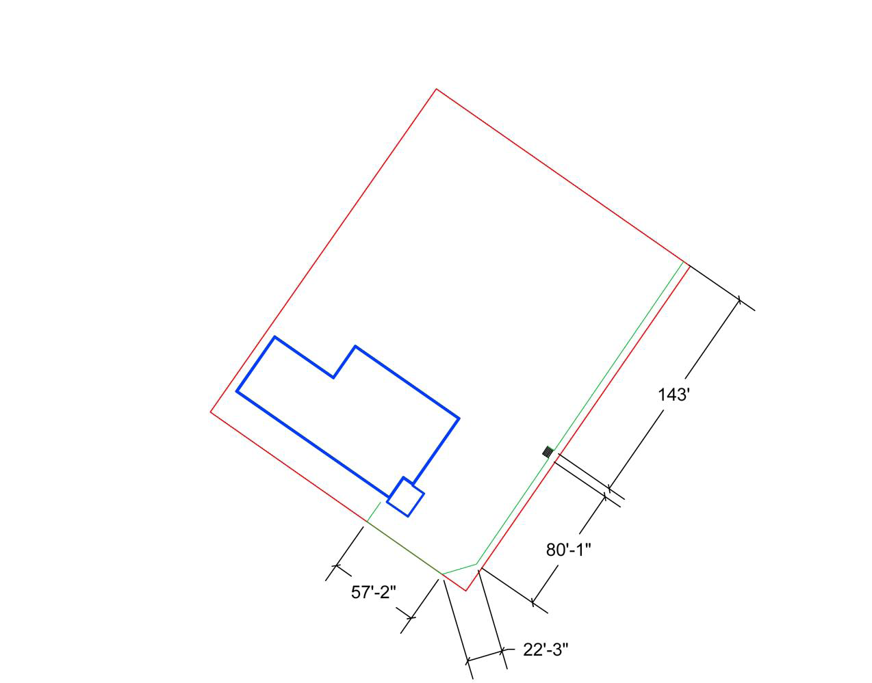

**The Area Of Landscaping Project**

The project calls for the installation of a two-tiered retaining wall from the glass doors on the south east corner of the church to the side and stairs on Main St, (eliminating the hill from the church lawn to the sidewalk) and a single four-foot wall from the sidewalk and stairs to the north end up to city hall.

A sprinkler system, with 31 sprinkler heads and a five-zone control will also be installed.

The voters approved the full project. A bid was accepted from Buffalo Floral and landscaping for both the landscaping ($28,900) and for the sprinkler system ($2,750) at a total cost of $31,650 Additional costs will include a sealer for the brick wall and the plumbing for the hook-up of the sprinkler system

The voters approved financing the project with money from the memorial fund ($19,320) and by securing three $5,000 debentures. Those willing to make a debenture with the congregation should speak to Doug Roush.

It is hoped the project will be completed this fall.

**SENIOR FELLOWSHIP**

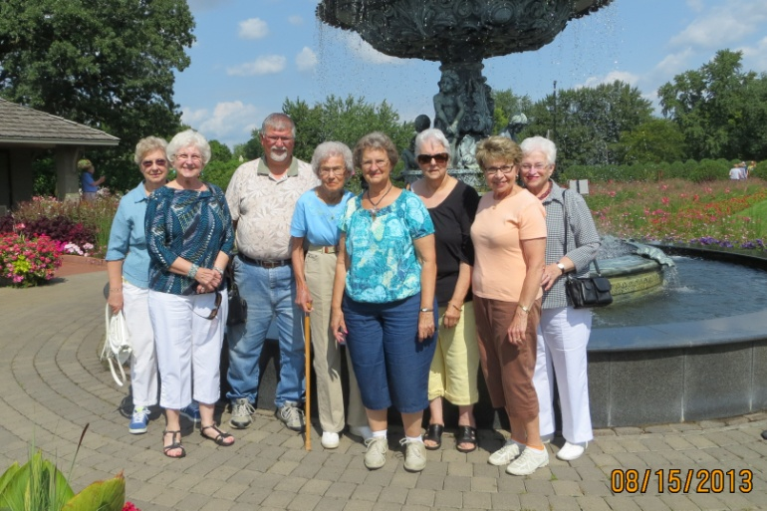

On Thursday, August 15, the Senior Fellowship visited the Munsinger Gardens in St Cloud. They also had lunch at the Coyote Moon Restaurant .

On Thursday, September 19, we will meet for a pot luck lunch (bring a dish to pass), a study of a portion of God’s Word and to discuss our plans and activities for the fall and winter.

The Senior Fellowship is sponsoring a trip to the Plymouth Playhouse to see the latest installment of the Church Basement Ladies “The Last (Potluck) Supper” on Sunday November 17th (see below for details). Anyone is invited to attend.

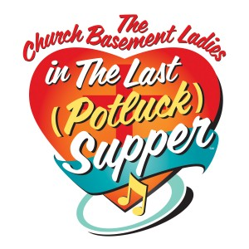

Sunday, November 17, 2:00pm

At the Plymouth Playhouse

Tickets - $30 each

Optional Dinner afterwards at the Green Mill Restaurant

Sign-up at Church

**C:\Users\church office\AppData\Local\Microsoft\Windows\Temporary Internet Files\Content.IE5\4M9S0069\MC900391134[1].wmf**

**MEN’S BREAKFAST BIBLE STUDY**

*Saturday, September 21 is the date for the September edition of the Men’s Breakfast Bible Study. On the menu to feed our souls will be Daniel 3. On the menu to feed our bodies will be ham & eggs. Men, make plans to attend!!!!*

*MC900048041[1]*

**SUNDAY SCHOOL**

The 2013-2014 Sunday School year will begin on Sunday, September 8 at 10:15 am. Our Sunday School is open to children preschool through 8th grade. It exists to help parents in bringing up their children in the training and instruction of the Lord. It is also an opportunity for outreach, by inviting the children of un-churched relatives and neighbors .

BIBLE STUDY OPPORTUNITIES:

It is that time of year when our regular Bible Studies begin again.



The **Sunday Morning Adult Bible Study** meeting on Sundays, (starting Sept 8, at 10:15 am in the basement fellowship hall. Coffee and refreshments are served, along with God’s Word. If your children are in Sunday School, you can stay and also grow in the knowledge of God’s Word and your Savior. We will be studying Paul’s letters to the Corinthians

The **Walnut Bible Study** meets Monday morning, 9:30 am – 10:30 am, in the family room at the Walnut Apartments at the west end of town. (right behind the former Nortog Meats). All are welcomed to attend. We will be starting a study based on the short book, *Positively Lutheran*.

The **Men’s Breakfast Bible Study** meet the third Saturday of the month, at 9:00 am. We begin with a hearty breakfast, followed by a heaping helping of God’s Word. We are currently looking at the book of Daniel.

***Makes to plans to attend one or more of these Bible Studies.***

CHOIR & HANDBELLS:

Our Handbells Choir will begin

C:\Users\church office\AppData\Local\Microsoft\Windows\Temporary Internet Files\Content.IE5\IXTE16XJ\MC900325250[1].wmf

practices again on Tuesday,

September 3 at 7:00 pm. If you

are interested in being part of the

Handbell Choir, speak with

Lorriane Roush.

The Choir will resume practices on Wednesday, September 4 at 8:00 pm. The Choir always welcomes new voices. If interested, speak to Chuck Landeck or just come to practice.

C:\Users\church office\AppData\Local\Microsoft\Windows\Temporary Internet Files\Content.IE5\IXTE16XJ\MC900417330[1].wmf

BANNER COMMITTEE**:** The Banner Committee will resume meetings on Monday, Sept 9th at 7:00 pm. If you would like to help, come to the meeting.

**WORSHIP COMMITTEE**

The Worship Committee will meet on Thursday, September 5th at 7:00 pm (rescheduled from August) to review tentative worship plans for the fall and winter

**C:\Users\church office\AppData\Local\Microsoft\Windows\Temporary Internet Files\Content.IE5\IXTE16XJ\MC900104132[1].wmf**

**CROSS LIGHTS**

*Cross LIGHTS will meet on Tuesday, Sept 3 at 7:30 pm. All the women of the congregation are invited to attend. You don’t have to be a member to attend.*